

**Customer Charter**

**Office of the Public Guardian Hadrian House Callendar Business Park Callendar Road Falkirk FK1 1XR**

Home-icon[1] **www.publicguardian-scotland.gov.uk**

cid:image002.png@01D10C22.8B7D4880 **@OPGScotland**

Nov 2023

**Who we are**

We are part of the Scottish Courts and Tribunals Service (SCTS) and deal with the applications in relation to the Adults with Incapacity (Scotland) Act 2000 (the Act).

We want to minimise any inconvenience and reduce anxiety to our customers by setting out in this document the quality and standards of service that customers can expect and our commitment to you. It will also give us feedback on how we handle complaints. You should feel confident that we will listen to you, provide you with accurate and relevant information and treat you with courtesy and consideration at all times. We can give information about the procedures of the Act and general matters but we cannot give customers legal advice.

**About us**

We have a statutory responsibility in Scotland to supervise people appointed by the court to make financial or property decisions on behalf of an incapable adult.

Our main functions areto:

**Values**

The way we deliver our services is led by our values, which are:

* **respect**
* **service, and**
* **excellence**

We aim to treat everyone fairly irrespective of age, disability, gender reassignment, marriage, civil partnership, pregnancy and maternity, race, religion or belief, sex or sexual orientation. Further information is available in the on the [SCTS equality and diversity webpages](https://www.scotcourts.gov.uk/about-the-scottish-court-service/the-scottish-civil-courts-reform/equality-and-diversity).

We will be professional and responsive, helpful and courteous in all our dealings with our customers. If we are unable to meet the standards set down here we will do our best to keep you informed and explain what is happening.

**What you can expect from us**

**Visiting us**

Our services are available from 9.00 a.m. to 5.00 p.m. Monday to Friday. We are happy to welcome members of the public to our building to visit or meet us. We operate an appointment system as this ensures that a suitable meeting space is available and that an appropriate person is on hand to assist with your enquiry.



Appointments are available throughout each working day until 4.45pm. Please note that we cannot assist with drafting powers of attorney nor do we provide a pre-registration checking service for powers of attorney.

Our staff will be polite, friendly and treat customers with respect. We will respect the privacy of customers.

Maps and directions can be provided if required to assist locating the office. Visitors travelling by car should note that car parking is limited; however road parking in the locality is usually possible.

In recognition that customers or staff may have allergies to or be afraid of animals, pets are not allowed in the office. Exceptions will be made for assistance dogs.



Information about [accessing our office building](https://www.publicguardian-scotland.gov.uk/general/contact-us/accessing-our-offices) is available from our website.

Disabled access to the building is provided and induction loops are installed in meeting rooms and the reception area.

If you need assistance please contact us to discuss the arrangements we can make for you.

**What you can expect from us**

|  |  |
| --- | --- |
| **Phone calls**  C:\Users\akerr\AppData\Local\Microsoft\Windows\Temporary Internet Files\Content.IE5\ALYBKR5W\white-male-1834136_640.jpg | * We aim to answer all telephone calls received between 9.00am and 5.00 pm. If the office is closed for public holidays or staff training, the answerphone message will confirm the date and time when the office will re-open for business. * If we cannot deal with your enquiry immediately, we will call you back at a mutually agreed time. * If you have hearing and/or speech difficulties and you have a text phone you can contact us using the [Relay UK service](https://www.ngts.org.uk/) * If you require the support of an interpreter when you contact us a telephone interpretation service is available.  To access this service, ask for telephone interpreting and the language required. * If you use British Sign Language (BSL) and wish to phone us using a sign language interpreter, you can use the online video relay interpreting service. For more information see [www.contactscotland-bsl.org](http://www.contactscotland-bsl.org/) |
| **Written correspondence**  **C:\Users\akerr\AppData\Local\Microsoft\Windows\Temporary Internet Files\Content.IE5\N4ZZ9LIN\post-1019869_640.jpg**  **C:\Users\akerr\AppData\Local\Microsoft\Windows\Temporary Internet Files\Content.IE5\T1KNMQMR\at-1019914_640.jpg** | * We will automatically acknowledge any enquiries received in our internet mailbox. * We will respond within 10 working days of receiving a general enquiry. When we are taking longer to reply we will update the automatic acknowledgement. * We will respond in writing or by telephone within 5 working days of receiving a request to search the public register. However there are times when this will take longer e.g. submitting a request for multiple searches. * We will explain things helpfully in plain English and avoid using technical and legal jargon. * We will respond to you in a way that is suitable to your needs. Please tell us if you have a preference. * We provide a post box outside the main entrance door if you wish to hand deliver documentation to us. |
| **Information** | * We will provide individual copies of guidance leaflets covering a range of procedures relating to the Act. A variation of the standard format will be made available on request. All leaflets can be viewed on the website. * We will provide guidance notes written in plain English. |

**Individual requirements -** should you have any other individual requirements not mentioned previously we will consider all reasonable requests and take all practical steps to meet them.

**Our standards for applications made under the Act**

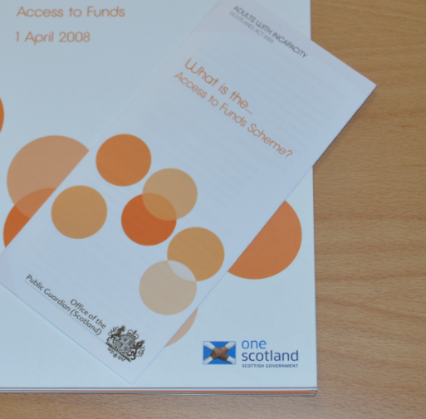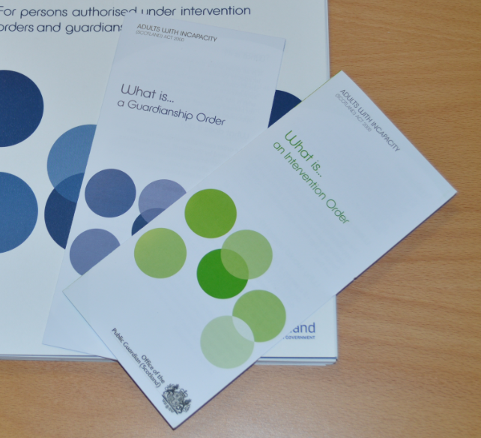

|  |
| --- |
| **Registration … we aim to register correctly completed:**   * Powers of attorney within 5 working days of receipt of a request to expedite registration * Access to funds within 30 working days of receipt. If the application is to be intimated out with Europe, we will register within 50 days of receipt * Intervention orders within 10 working days of receipt of the final interlocutor from court or when notified that the bond of caution is in place * Guardianship orders within 10 working days of receipt of the final interlocutor from court or when notified that the bond of caution is in place |
| **Guardianship processes … we aim to begin:**   * Processing inventory of estate and management plan documentation within 15 working days of receipt * Processing gift, recall and discharge applications within 5 working days of receipt * Processing applications for consent in principle to sell or purchase heritable property within 5 working days of receipt. We aim to process consent to a sale or purchase price within 5 working days of receipt * An initial risk assessment on all accounts received within 10 working days of receipt. Annual accounts will be reviewed within 60 working days of receipt. |
| **Access to funds … we aim to begin:**   * Processing annual review documentation within 30 working days of receipt |
| **Investigations … we aim to risk assess:**   * Investigation enquiries within 2 working days of the concern being lodged.   (This assessment lets us identify if we can commence an investigation or not). |

**Freedom of Information**

The Freedom of Information (Scotland) Act 2002 gives a general right of access to all types of recorded information held by public authorities. If you want to make a request under the Freedom of Information (Scotland) Act 2002 you should write to the Public Guardian at the address provided.

If you wish to know more about our plans for the future or how we have performed against the standards set out, you can view our monthly performance figures on our website [www.publicguardian-scotland.gov.uk](http://www.publicguardian-scotland.gov.uk)

A copy of the report is also displayed in our reception area and on notice boards in interview rooms.

****

**Listening to customers**

We are committed to achieving standards set out in this document. We will measure the success of our standards through regular reviews, consulting those who have used our services and by working in partnership with other agencies which have a mutual interest in the provisions of the Act.

**Feedback**

Many people are pleased with the high standard of service provided. We would like to hear from you if you have been dissatisfied with our service as this helps us to recognise what is valued and ensure we build upon this. You can also offer your compliments using our [feedback form](https://www.publicguardian-scotland.gov.uk/docs/librariesprovider3/general/pdf-documents/customer-feedback-form-opg-newest.pdf?sfvrsn=d18405_2)comment cards in the office building or contact us by telephone, by email or by post.

We do take seriously the views of people who use our service. We have changed our service as a result of people letting us know their experience. Examples of changes we have made and agreed to work on can be viewed on our ‘[You said… We did… list’](http://www.publicguardian-scotland.gov.uk/meta1/you-said-we-did) which is published on our website and available throughout our office.

**Complaints**

We recognise that we will not get it right every time, despite our best efforts. When we get it wrong, we want you to tell us about it. All complaints will be taken seriously and dealt with impartially and in confidence.

Ordinarily, we operate a 2 stage complaints procedure. Our feedback form sets out how to make a complaint and how complaints will be dealt with. If we receive a complaint, we aim to reply within 5 working days. In some cases we need to investigate further. In these instances, we aim to reply within 20 working days. If we are unable to provide you a full reply within these timescales, we will explain why and provide you with a revised timescale for completion.

****

You can write, phone or email to us:

The Office of the Public Guardian Hadrian House Callendar Business Park Callendar Road Falkirk FK1 1XR

DX 550360 Falkirk 3

Tel: 01324 678300 E-mail: [opgfeedback@scotcourts.gov.uk](mailto:opgfeedback@scotcourt.gov.uk)  X (Twitter): @OPGScotland